FS80 Bracket

Rev 02

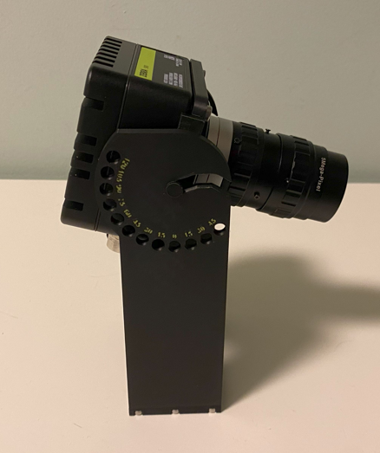

Project Goals
Create a support bracket than can simplify the test of an FS80.
The bracket is not intended for field installation but only for short term lab test, so using 3D Printed bracket is not critical.
Rev 02:
- improve the text representing the angles on the shoulder
- use 4 mm screws also for the register (instead of 6 mm).
- Use longer screws (M4x10) without embedding the screw head in the material.

Mounting Drawings
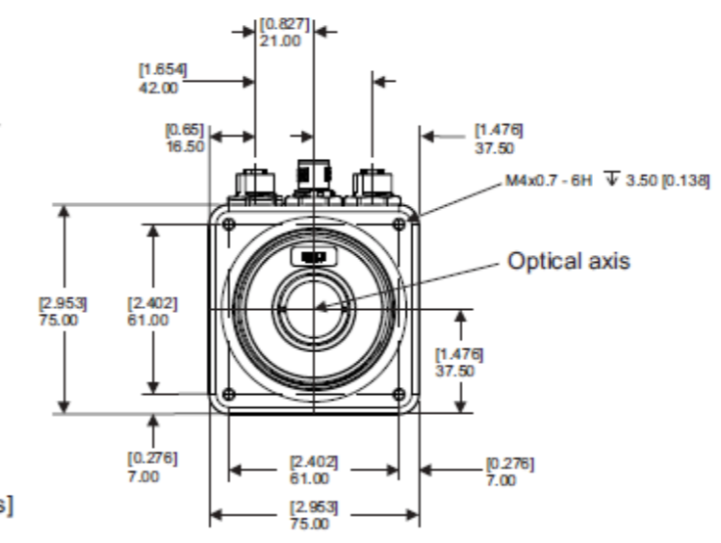

Design

FS80 Bracket
Mounting Screws: 4x M4x10 mm length
Support Pin: Diameter 5.8 mm, height 7 mm

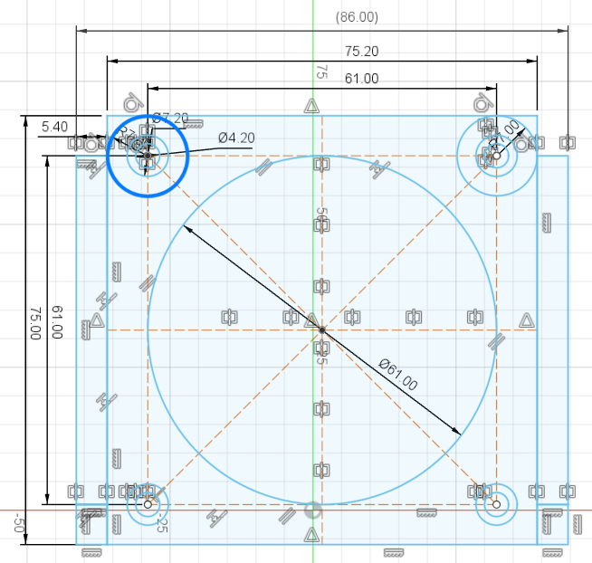

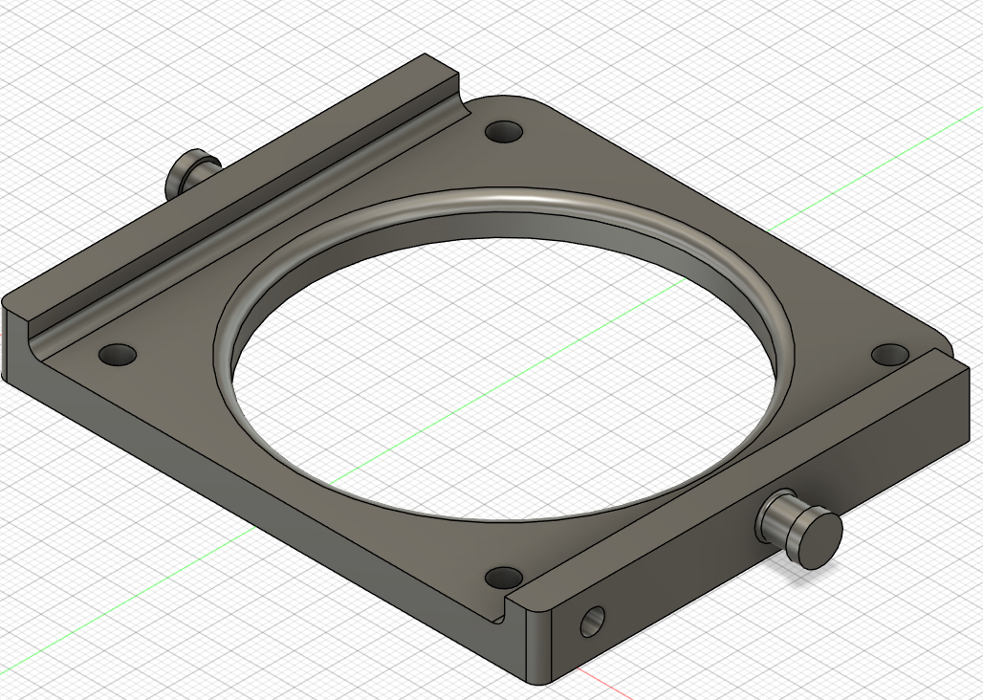

FS80 Shoulder
Center slot 6 mm
Locking screw: 6 mm x 10 mm dept
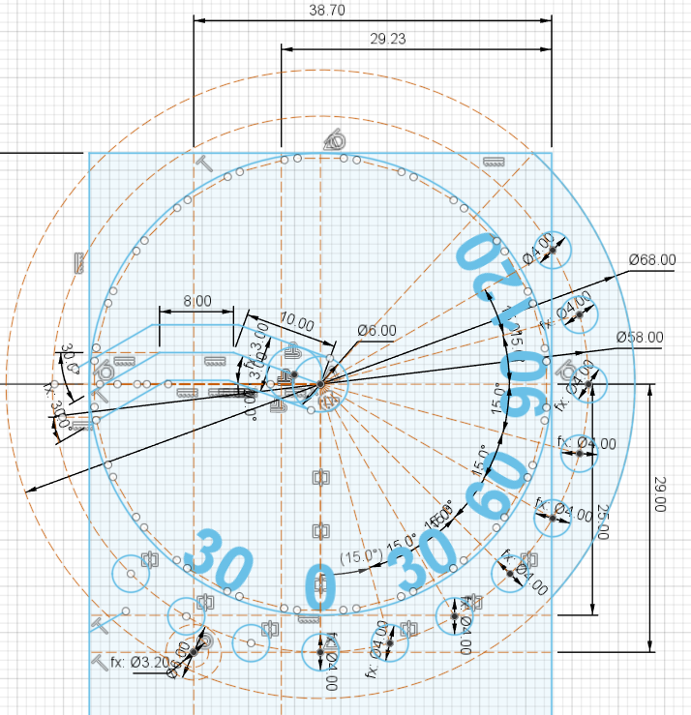 | 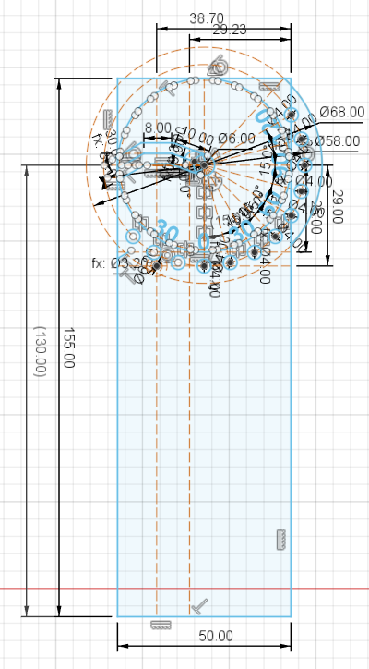

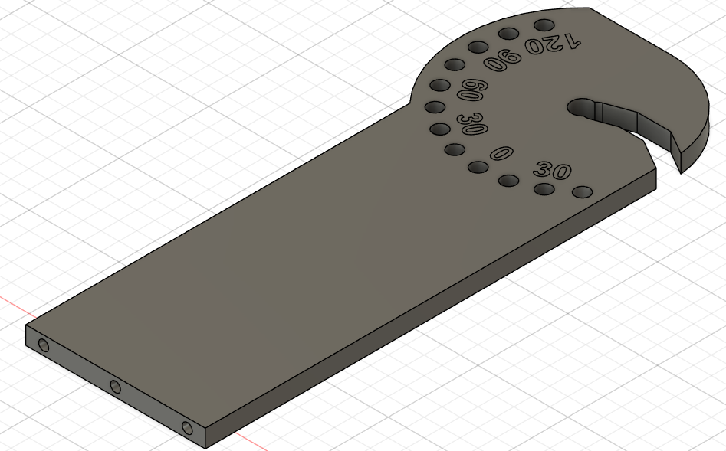

There are 2 identical shoulders.

FS80 Bracket Base
Mounting screws: 6x 3 mm diameter x 16 mm long
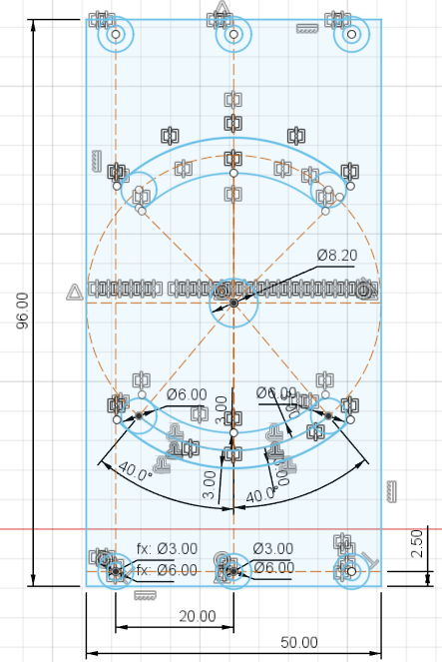

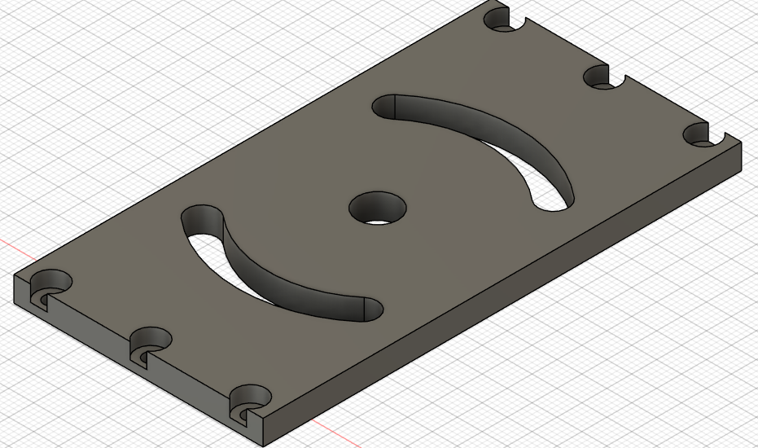

Components Pictures

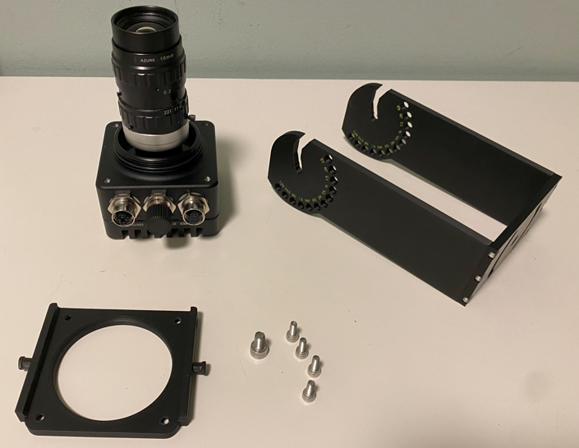

For Next iteration
Nothing.

